**Algorithmic Thinking in Problem Solving**

**Warm-Up!**

For each of the following problems, provide at least one solution. State the time and space complexities of your solutions.

**Problem 1:** Reverse all the words in a string of words and spaces / tabs while preserving the word order and spacing.

Example**:** “moo cow bark dog” -> “oom woc krab god”

**Problem 2:** Write a function that takes as input a string and returns whether the parenthesis are "balanced".

If you solve this quickly, add the following difficulty: the string may also contain "[]" or "{}". Return whether all three types of brackets are balanced.

**Problem 3:** Write a function to return a copy of a list of strings with duplicates removed. Preserve order in the original list as much as possible (keep first occurrence).

### If you solve this quickly, reimplement the function, but only keep the strings that appear at least *n* times in the list (n is specified as a parameter).

### Example: ["foo", "bar", "baz", "foo", "bar"] -> ["foo", "bar", "baz"]

**Problem 4:** Given an array of integers, return the **indices** of the two numbers that add up to a specific target.

You may assume that each input has ***exactly*** one solution, and you may not use the *same* element twice.

Example

Given nums = [2, 7, 11, 15], target = 9,

return [**0**, **1**] because nums[**0**] + nums[**1**] = 2 + 7 = 9

**Problem 5:** Return the longest contiguous substring of 2 distinct characters from an input string.

Example

input: abbaacab return: abbaa

input: abcefabbabaabefghghfa return: abbabaab

input: aabceddddcdccecabceftg return: ddddcdcc

input: acbabbcbca return : bbcbc

Spend at most 1 hour trying to solve each of the problems. If you are unable so solve the problem after 1 hour, Google the problem and find a solution, then do the following:

For Question5

1. Trace the solution using a concrete instance of the problem

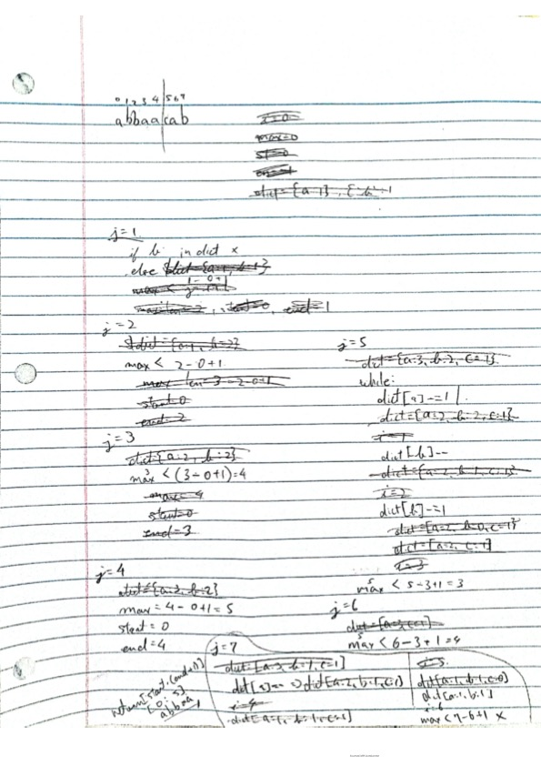

1. What prevented you from solving the problem?

🡪 Simplify the problem and making too many variables instead of deleting what I don’t need throughout the program.

1. What did you learn? Did you have to Google a little more to understand the solution?

🡪 I learned that, solving a problem is not just implementing and using any variable there is. If not need it, or it is a variable that it won’t be used any more, delete it and use that data in a useful manner.

1. What would you do differently in the future if you were presented with a similar problem?

🡪 I would first, reuse the variable there is. In this problem, I used dict as to count how many occurrences but not to subtract in order to delete unneeded variable. I learned that I need to think more with flexibility to reuse any variable in order to avoid having another variable and to solve the problem.